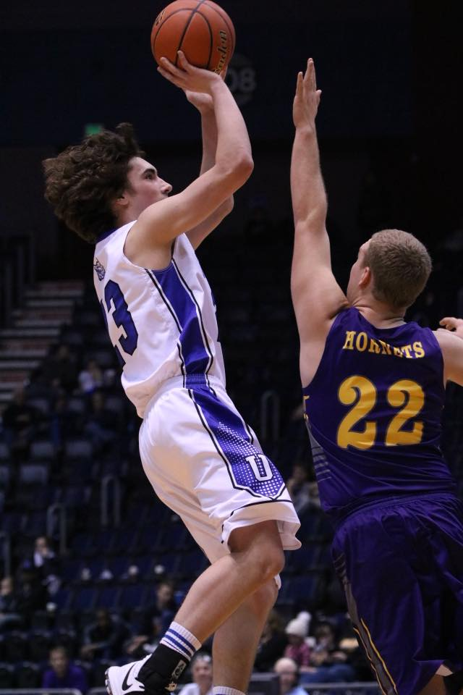

May 29th – June 1st

Upton High School

Bobcats

Boys Basketball



PARENTAL CONSENT

Please Print

Camper Name: Person to contact in case of emergency:

Relation: Phone Number:

Release Form: I hereby authorize the Weston County

School District #7 to act for me according to their best

judgment in any emergency requiring medical attention

and I hereby waive and release Weston County School

District #7 and its affiliates or any camp staff from

any and all liability for any injuries or illnesses incurred

while at the camp. I understand that the violation of

camp rules may result in dismissal from the camp

with all tuition forfeited. I likewise release images

and photos of my child to be used to promote

Bobcat Basketball and the Junior Bobcat program.

I declare that I am the father/mother/legal guardian of the above named minor.

Parent’s/Guardian Signature

Additional questions contact:

Coach Joe Samuelson

Head Boys’ Basketball

Email: jsamuelson@weston7.org

Cell Phone: (605) 641-7314



WELCOME

Our summer basketball camps provide an opportunity for players to experience the excitement surrounding the Bobcat Basketball Program. Our camps give athletes the necessary tools to become a complete basketball player in a competitive and fun environment.

Go Cats,

Joe Samuelson

Joe Samuelson

Head Basketball Coach

Camps are directed by the Boys’ Basketball staff with the help of Bobcat players and the permission of Weston County School District #7.



CAMPS

SESSION 1 – 2nd-5TH GRADE

8:30-10:00

SESSION 2 – 6TH-8TH GRADE

10:30-12:00

SESSION 3 – 9TH-12TH GRADE

1:00-3:00

INFORMATION & REGISTRATION CAMP DESCRIPTION CAMP APPLICATION

## SKILLS CAMP

This camp will focus on establishing a solid foundation of fundamentals for campers to build on individually. Campers are grouped by age and are taught both offensive and defensive skills that will challenge them to become better basketball players. No one camp can make the difference in a player, rather what is learned from the camp and practiced individually is what sets athletes apart.

LOCATION: UPTON HIGH SCHOOL

CAMP TIMES

May 29 – June 1

Session 1…………………………………. 8:30-10:00am Session 2…………………………………. 10:30-12:00pm

Session 3…………………………………. 1:00-3:00pm

REGISTRATION TIMES

May 29th – Registration starts at:

Session 1…………………………………. 8:00am

Session 2…………………………………. 10:00am

Session 3…………………………………. 12:30pm

## SKILLS TO BE LEARNED

Campers in attendance will learn important fundamentals starting with the basics. Footwork, stance, passing, ball-handling, and shooting will be the main focuses. Campers will also be introduced to the main concepts of team offense and defense. They will learn the basics of a motion offense as well as help defense.

Name:

Address:

City: Zip:

Parent/Guardian Phone:

T-Shirt Size (Circle One): Youth- S M L Adult- S M L XL

Parent/Guardian Email:

Grade (Fall 2018) Age

Please circle or mark the appropriate session:

Session 1 (2nd – 5th Grade)

* Per Camper….…….$35

Session 2 (6th – 8th Grade)

* Per Camper….…….$35

Session 3 (9th – 12th Grade)

* Free to Upton Bobcat players

*Please make checks payable to **WCSD #7**.

Send application with camp tuition to:

(Or bring the application and tuition with you to camp)

WCSD #7- Business Office

PO Box 470

Upton, WY 82730

Registration may also be completed online at bobcatbasketball7.weebly.com. Walk up campers will be welcome on any day of the camp but will still need to pay the full registration fee unless worked out otherwise.

# TRADITION OF PRIDE AND EXCELLENCE

The Bobcat Basketball program and athletes coming through it experience success very few other teams get to experience. The Bobcat Basketball program has produced:

* 8 straight State Tournament appearances (3rd-2015 & 2nd- 2016)
* 2A State Semifinals - 2018
* 1A Northeast Conference Champions (2013 & 2016)
* 1A East Regional Champions, 2016
* 2A East Regional 3rd Place, 2017 & 2018

**Last 5 years:**

* 8 All-State Selections
* 14 All-Conference Selections
* 2 Conference Players of the Year (1 North All Star)
* Four 20-Win Seasons
* 100-37 Record

## 

## FUN-DEMANTALS

This camp is offered to young players that are just beginning their basketball careers. Campers will receive instruction based on their experience and will enjoy playing fun games every day. This camp setting will be energetic and informative for beginners and experienced players. Campers will participate in fun games and competitions while also helping to develop important fundamental skills.

**In addition, all participants will receive a camp t-shirt!**

