Bobcat Basketball
2017 Fall Boys’ Basketball Clinic
September 28th & 30th
Bobcat Basketball
The goal of these camps is to develop the youth athletes coming up to the Bobcat Basketball program. All children are encouraged to participate.

With 7 straight State Tournament appearances (2nd- 2016), Bobcat Basketball has developed a…

Tradition of Pride and Excellence

In the last five years, Bobcat Basketball has produced:
Regional Champions – 2016
2A East Regional 3rd Place – 2017
Conference Champions – 2013 & 2016
7 All-State Selections
15 All-Conference Selections
3 Conference Players of the Year
2 Wyoming Coaches Association North All-Stars
99-39 Record (23-4, 2015-2016 Season)
Dates & Times: September 28th & 30th at Upton HS Gym
- Sept. 28th – 2nd-5th Grade 5:00 to 6:30 PM
- Sept. 28th – 6th-8th Grade 6:30 to 8:00 PM
- Sept. 30th – 2nd-5th Grade 9:00 to 10:30 AM
- Sept. 30th – 6th-8th Grade 10:30 AM to Noon
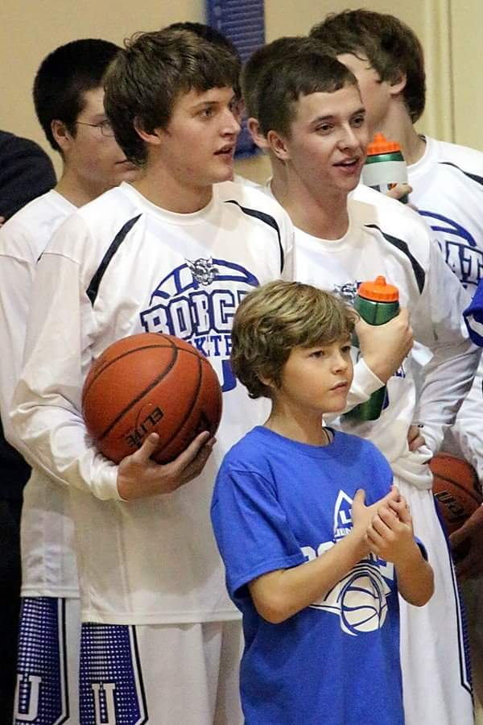
Cost: $20 per athlete (Includes clinic t-shirt)
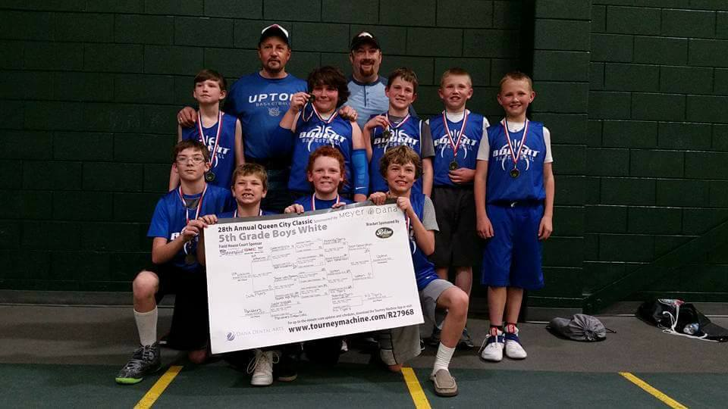

Camp Includes:
Athletes participating in the camp will receive:

- 2 instructional clinics
- Be included in the Junior Bobcat Program
- A Junior Bobcat T-Shirt
- Instruction for fundamental
basketball skills
- Background into a motion offense

Contact:
- Clinic registration along with its tuition can be brought to the clinic or mailed to WCSD #7 at PO Box 470, Upton, WY 82730.
- For more information, you can contact head coach Joe Samuelson by email or by phone at the school.
jsamuelson@weston7.org.
(307) 468-9331

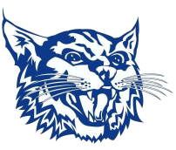

Registration (Please tear this portion off and bring with you to the clinic along with the clinic tuition):
Athlete name:________________________________ Grade:_______ Birthday:_____________ T-Shirt Size: Youth- S M L Adult - S M L XL
Parent/Guardian Email:____________________________________________ May we contact you about Junior Bobcat Opportunities? Yes No

Emergency Contact: __________________________________ Phone:____________________________
Waiver: I hereby authorize the Weston County School District #7 to act for me according to their best judgment in any emergency requiring medical attention and I hereby waive and release Weston County School District #7 and its affiliates or any camp staff from any and all liability for any injuries or illnesses incurred while at the camp. I authorize the release of images, that may include my child, taken at the camp to promote Weston County School District #7 and its affiliates. I understand that the violation of camp rules may result in dismissal from the camp with all tuition forfeited.
I declare that I am the father/mother/guardian of the above named minor. ________________________________ Date:__________________
Registration (Please tear this portion off and bring with you to the clinic along with the clinic tuition):

Athlete name:_______________________ Grade:_______ Birthday:_____________ T-Shirt Size: Youth- S M L
Adult - S M L XL

Parent/Guardian Email:________________________________________ May we contact you about Junior Bobcat Opportunities? Yes No
Emergency Contact: _________________________ Phone:_________________

Waiver: I hereby authorize the Weston County School District #7 to act for me according to their best judgment in any emergency requiring medical attention and I hereby waive and release Weston County School District #7 and its affiliates or any camp staff from any and all liability for any injuries or illnesses incurred while at the camp. I authorize the release of images, that may include my child, taken at the camp to promote Weston County School District #7 and its affiliates. I understand that the violation of camp rules may result in dismissal from the camp with all tuition forfeited.

I declare that I am the father/mother/guardian of the above named minor. ____________________________ Date:____________
Registration (Please tear this portion off and bring with you to the clinic along with the clinic tuition):

Athlete name:_______________________ Grade:_______ Birthday:_____________ T-Shirt Size: Youth- S M L
Adult - S M L XL

Parent/Guardian Email:________________________________________ May we contact you about Junior Bobcat Opportunities? Yes No
Emergency Contact: _________________________ Phone:_________________

Waiver: I hereby authorize the Weston County School District #7 to act for me according to their best judgment in any emergency requiring medical attention and I hereby waive and release Weston County School District #7 and its affiliates or any camp staff from any and all liability for any injuries or illnesses incurred while at the camp. I authorize the release of images, that may include my child, taken at the camp to promote Weston County School District #7 and its affiliates. I understand that the violation of camp rules may result in dismissal from the camp with all tuition forfeited.

I declare that I am the father/mother/guardian of the above named minor. ____________________________ Date:____________

