Bobcat Basketball
2018 Fall Coed Basketball Clinic
September 27th & October 6th
Bobcat Basketball
The goal of these camps is to develop the youth athletes coming up to the Bobcat Basketball program. All children are encouraged to participate.

With a girls’ 1A record of 33-10 over the last four years and 8 straight Boys’ State Tournament appearances (2nd- 2016), Bobcat Basketball has developed a…

Tradition of Pride and Excellence

The high school boys’ and girls’ basketball programs are partnering to provide an opportunity for all youth in the community to develop their basketball skills.

All boys and girls between the grades 2nd through 8th are invited to attend! There will be a mixture of whole coed instruction as well as time to split among the boys’ and girls’ programs for further development.
Dates & Times: September 27th & Oct. 6th at Upton HS Gym
- Sept. 27th – 2nd-5th Grade 6:00 to 7:30 PM
- Sept. 27th – 6th-8th Grade 7:30 to 9:00 PM
- Oct. 6th – 2nd-5th Grade 8:30 to 10:00 AM
- Oct. 6th – 6th-8th Grade 10:00 to 11:30 AM
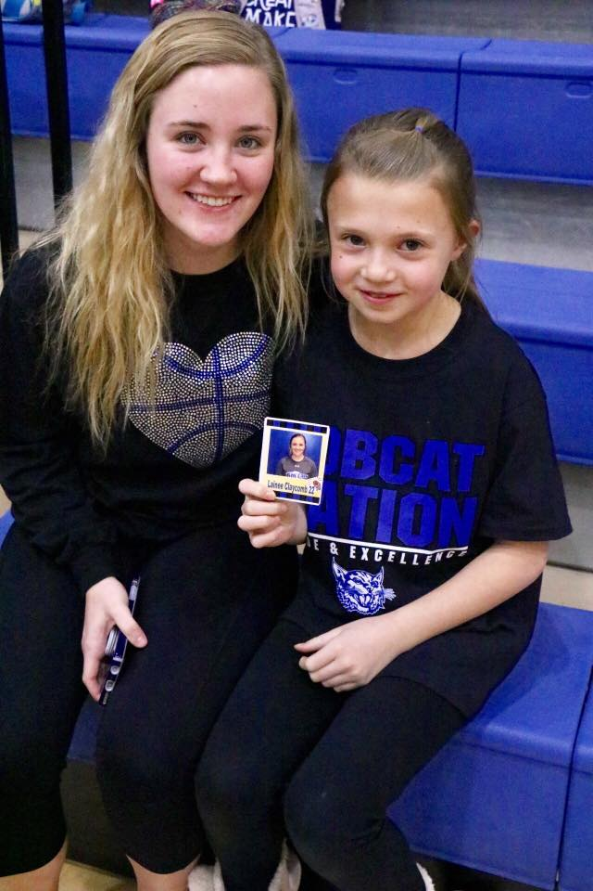
- Cost: $20 per athlete (Includes clinic t-shirt)
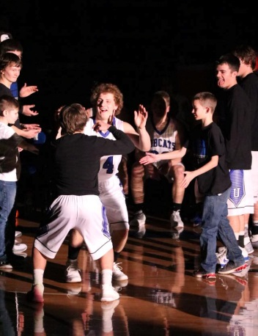

Camp Includes:
Athletes participating in the camp will receive:

- 2 instructional clinics
- Be included in the Junior Bobcat Program
- A Junior Bobcat T-Shirt
- Instruction for fundamental
basketball skills
- Background into a motion offense

Contact:
- Clinic registration along with its tuition can be brought to the clinic or mailed to WCSD #7 at PO Box 470, Upton, WY 82730.
- For more information, you can contact head coach Joe Samuelson by email or by phone at the school.
jsamuelson@weston7.org.
(307) 468-9331

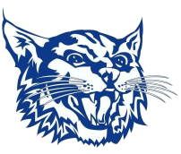

Registration (Please tear this portion off and bring with you to the clinic along with the clinic tuition):
Athlete name:________________________________ Grade:_______ Birthday:_____________ T-Shirt Size: Youth- S M L Adult - S M L XL
Parent/Guardian Email:____________________________________________ May we contact you about Junior Bobcat Opportunities? Yes No

Emergency Contact: __________________________________ Phone:____________________________
Waiver: I hereby authorize the Weston County School District #7 to act for me according to their best judgment in any emergency requiring medical attention and I hereby waive and release Weston County School District #7 and its affiliates or any camp staff from any and all liability for any injuries or illnesses incurred while at the camp. I authorize the release of images, that may include my child, taken at the camp to promote Weston County School District #7 and its affiliates. I understand that the violation of camp rules may result in dismissal from the camp with all tuition forfeited.
I declare that I am the father/mother/guardian of the above named minor. ________________________________ Date:__________________
Registration (Please tear this portion off and bring with you to the clinic along with the clinic tuition):

Athlete name:_______________________ Grade:_______ Birthday:_____________ T-Shirt Size: Youth- S M L
Adult - S M L XL

Parent/Guardian Email:________________________________________ May we contact you about Junior Bobcat Opportunities? Yes No
Emergency Contact: _________________________ Phone:_________________

Waiver: I hereby authorize the Weston County School District #7 to act for me according to their best judgment in any emergency requiring medical attention and I hereby waive and release Weston County School District #7 and its affiliates or any camp staff from any and all liability for any injuries or illnesses incurred while at the camp. I authorize the release of images, that may include my child, taken at the camp to promote Weston County School District #7 and its affiliates. I understand that the violation of camp rules may result in dismissal from the camp with all tuition forfeited.

I declare that I am the father/mother/guardian of the above named minor. ____________________________ Date:____________
Registration (Please tear this portion off and bring with you to the clinic along with the clinic tuition):

Athlete name:_______________________ Grade:_______ Birthday:_____________ T-Shirt Size: Youth- S M L
Adult - S M L XL

Parent/Guardian Email:________________________________________ May we contact you about Junior Bobcat Opportunities? Yes No
Emergency Contact: _________________________ Phone:_________________

Waiver: I hereby authorize the Weston County School District #7 to act for me according to their best judgment in any emergency requiring medical attention and I hereby waive and release Weston County School District #7 and its affiliates or any camp staff from any and all liability for any injuries or illnesses incurred while at the camp. I authorize the release of images, that may include my child, taken at the camp to promote Weston County School District #7 and its affiliates. I understand that the violation of camp rules may result in dismissal from the camp with all tuition forfeited.

I declare that I am the father/mother/guardian of the above named minor. ____________________________ Date:____________

